2013 Core-to-Core Strategic Meeting

21st June 2013
Hannover Medical School

Program

Freiday, Juni 21th

Get Together at 10.00 a.m.

Part 1. Core to Core Strategic Meeting

10:00 - 10:05 Opening and welcome greeting

Axel Haverich

10:05 - 10:25 Presentation from JSPS Bonn office

Keiichi Kodaira

10:25 -10:40 TE Valve Project

Axel Haverich

10:40 - 10:55 Core to Core Summer Seminar in Helsinki
19th & 20th August, 2013

Ari Harjula

10:55 - 11:10 Core to Core Symposium in Osaka
25th - 27th November, 2013

Yoshiki Sawa

11:10 - 11:30 Discussion

Part 2. Presentation:

11:30 - 12:15 International Research Consortium

Masamichi Ono

Participants
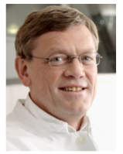
Axel Haverich, MD, PhD.
Professor and Director,
Dept. of Cardiac, Thoracic,
Transplantation, and Vascular Surgery
Hannover Medical School
Hannover, Germany

Ari Harjula, MD, PhD.
Professor and Director,
Dept. of Cardiothoracic Surgery
University of Helsinki
Helsinki, Finland

Yoshiki Sawa, MD, PhD.
Professor and Director,
Dept. of Cardiovascular Surgery
Osaka University
Osaka, Japan

Participants from Hannover
Andres Hilfiker
Participant from Osaka

Takayoshi Ueno
Soichiro Funaki
Yasumasa Tsukamoto
Hideto Ozawa
Shunsuke Saito
Masamichi Ono

Ingo Kutschka
Hassina Baraki
Serghei Cebotari
Igor Tudorache
Thomas Breymann
Samir Sarikouch
Dietmar Böthig
Dmitry Bobylev
Robert Zweigerdt
Ina Gruh
George Kensah
Tilman Fabian
Michael Harder
Martin Börgel
Special Guest

Keiichi Kodaira
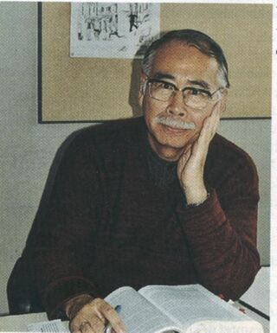
Director
JSPS Bonn Office

Keiichi Kodaira
Professor of Astrophysics, Japan
1961 to 1963 doctoral studies at the University of Kiel, 2000 Visiting Professor at the TU Berlin

"It's all about unravelling the origin of the universe"

In October 1999, Prof. Dr. Keiichi Kodaira came a bit closer to his dream of unravelling the origin of the universe. It was at his instigation that the world's largest telescope was opened on the 4,200 m. high peak of Mount Mauna Kea on Hawaii. For more than ten years - from 1980 to 1991 - Kodaira had fought for the financial resources to build the telescope and he had to wait a further eight years before he could first look into the far reaches of the universe with the eight metre, optical-infrared telescope. The telescope called SUBARU (the Japanese name for the Pleiades) has already helped find a galaxy which broke all records with a distance of 12.8 billion light years from Earth.
Kodaira gained his doctorate at the University of Kiel in the early 1960s, a time in which astronomers in Japan were above all engaged in theoretical research due to the lack of technical equipment. The German doctorate was followed by a doctorate in astronomy at Tokyo, since his German degree had not been recognised. Kodaira researched and taught at the University of Tokyo, the California Institute of Technology, and the University of Heidelberg. In September 2001 he was the first Japanese to receive the distinguished Karl Schwarzschild Medal for his services as an excellent astronomer. For six years (up to 2000) he held the position of General Director of the National Astronomy Observatory of Japan (NAOJ). Today, the emeritus professor is still actively researching and teaching: as President of the Graduate University for Advanced Studies "Sokendai", he is dedicated especially to promoting an integrative research culture.

Venue

Hannover Medical School,
Carl-Neuberg-Str.1
30625 Hannover, Germany

Core Institution Address

Dept. of Cardiovascular Surgery
Osaka University Graduate School of Medicine
Yamada-oka 2-2, Suita, 565 0871, Osaka, Japan
Telefon: 81-6-6879-3154
Miss. Atsuko Shimai

Dept. of Cardiac, Thoracic, Transplantation and Vascular Surgery
Hannover Medical School
Carl-Neuberg Stra.1, 30625 Hannover, Germany
Telefon: 49-511-532-9397
Masamichi Ono. MD.
E-Mail: ono.masamichi@mh-hannover.de

Dept. of Cardiothoracic Surgery
University of Helsinki, Meilahti Hospital
Haartmaninkatu 4, 00029, Helsinki, Finland
Telefon: 358-9-4717-2305
Mrs. Kaisu-Maarit Pelkonen

Please refer to the following web site

http://jsps-osaka-u.jpn.org/

